EXPERIMENT 6
BASIC IMAGE HANDLING AND PROCESSING USING ERODE FUNCTION
AIM
To perform basic image handling and processing operations using Python and OpenCV by reading an image and applying the Erode function to the input image.
REQUIREMENTS
Software Requirements:
• Python 3.x
• OpenCV (cv2)
• NumPy
• Notepad
• Command Prompt
• Windows Operating System
PROCEDURE
- Install Python on the computer.
- Install OpenCV using the command pip install opencv-python.
- Install NumPy using the command pip install numpy.
- Create a folder named opencv on the Desktop.
- Place the input image color_fruits.png inside the opencv folder.
- Open Notepad and type the Python program.
- Save the program as image_erosion.py inside the opencv folder.
- Open Command Prompt.
- Navigate to the opencv folder using the commands cd Desktop and cd opencv.
- Run the program using the command python image_erosion.py.
- The original image and eroded image will be displayed.
PROGRAM
import cv2
import numpy as np
image = cv2.imread("color_fruits.png")
if image is None:
print("Image not found")
else:
kernel = np.ones((5, 5), np.uint8)
eroded_image = cv2.erode(image, kernel, iterations=1)

cv2.imshow("Original Image", image)
cv2.imshow("Eroded Image", eroded_image)

cv2.waitKey(0)
cv2.destroyAllWindows()
COMMANDS USED
cd Desktop
cd opencv
python image_erosion.py
INPUT
The input image used in this experiment is color_fruits.png, which contains fruits with different colors.
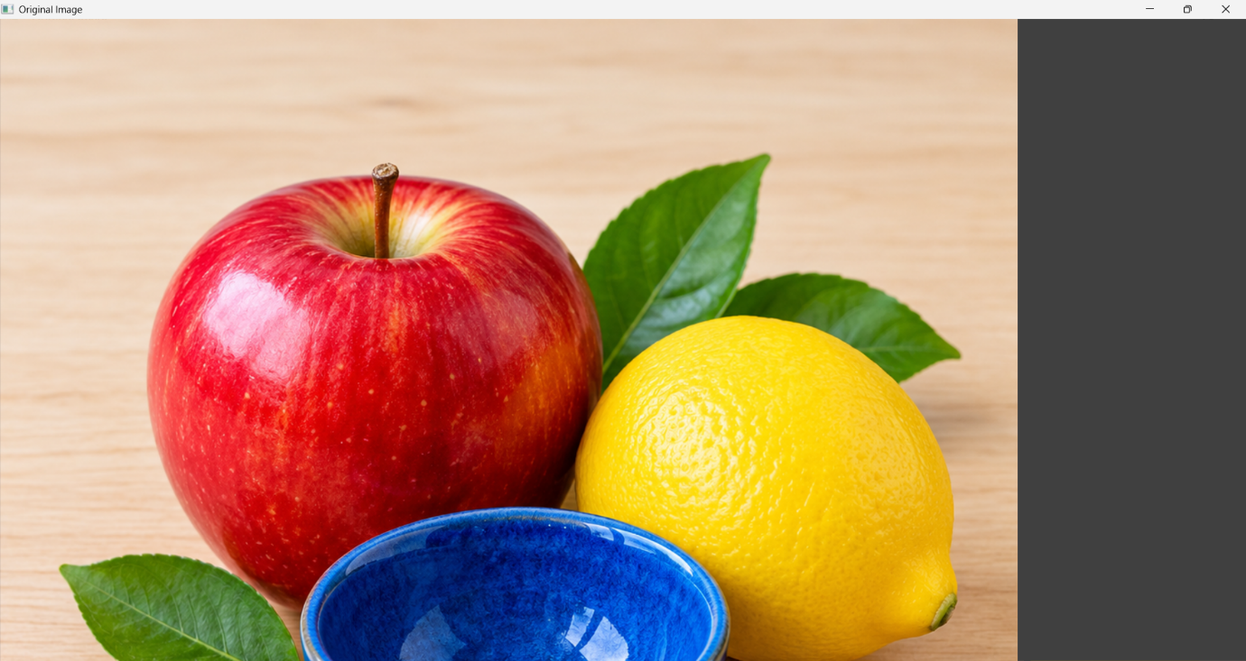
OUTPUT
The original image and the eroded image are displayed. The erosion operation reduces the size of foreground regions and makes their boundaries smaller.
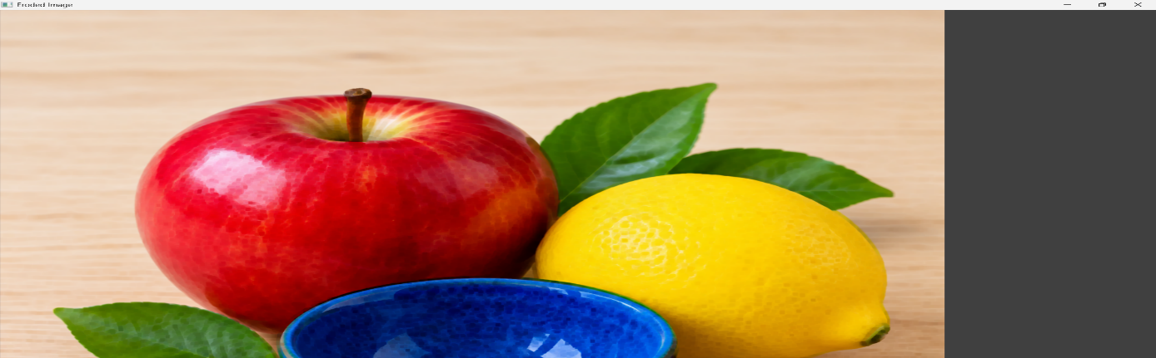

RESULT
Thus, basic image handling and processing operations were performed successfully using Python and OpenCV with the Erode function.

